|  |  |
| --- | --- |
| Image result for Worst-case asymptotic analysis  Worst-case asymptotic analysis | Abstract  In computer science, the worst-case complexity (usually denoted in asymptotic notation) measures the resources an algorithm requires in the worst -case.  Roxanne Meeks, Bernard Smith, Rasheed Walcott |

Contents

Worst Case Asymptotic Analysis 2

Admin.java 2

Driver.java 5

OpeningHours.java 7

Places.java 9

PlacesNode.java 15

PlacesTree.java 16

RequestNode.java 20

RequestQueue.java 21

RequestStack.java 23

TreeNode.java 24

Visitor.java 25

# Worst Case Asymptotic Analysis

## Admin.java

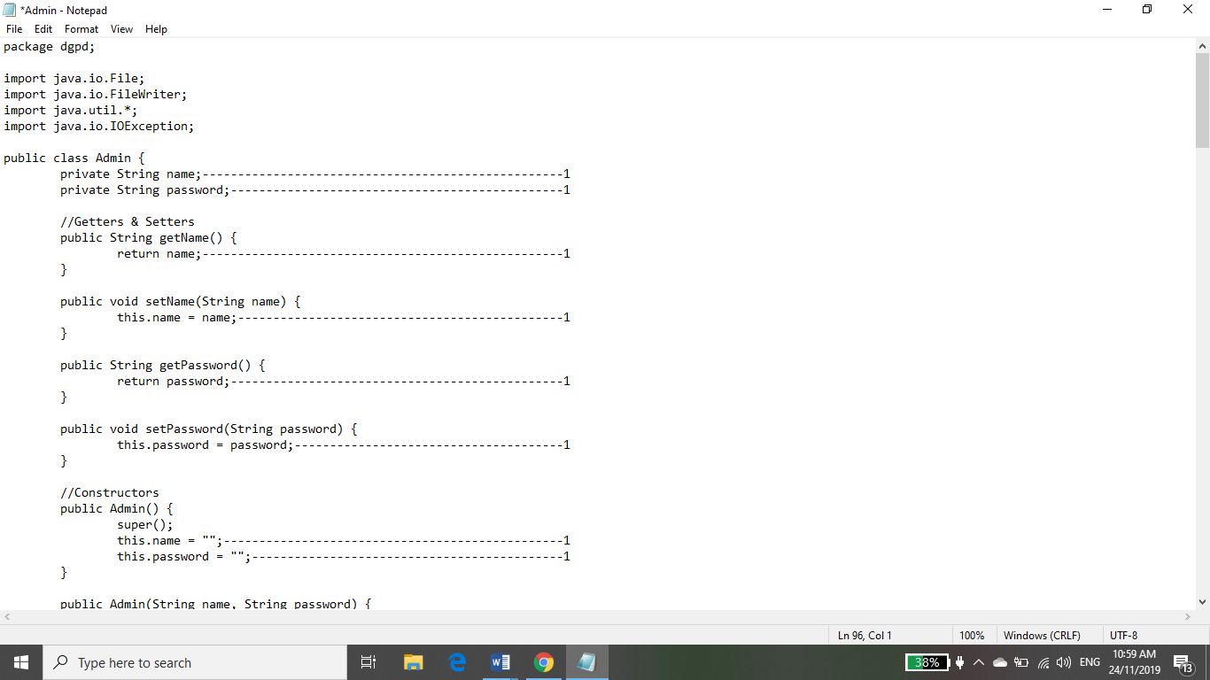

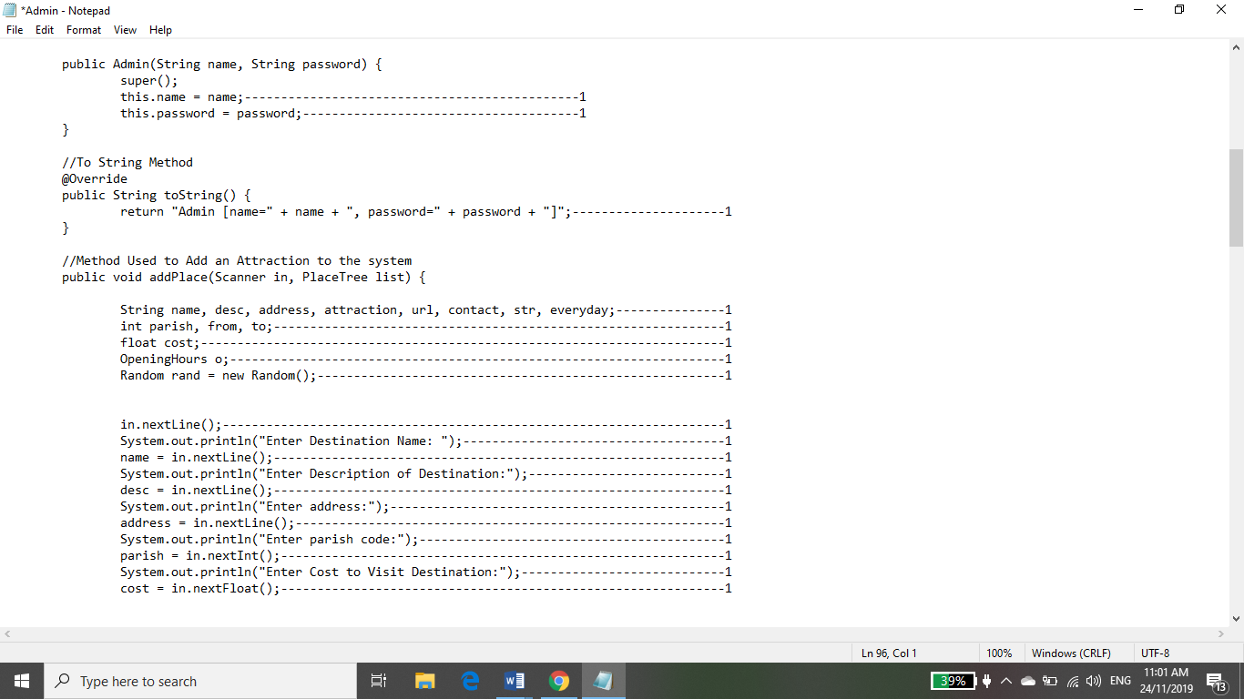

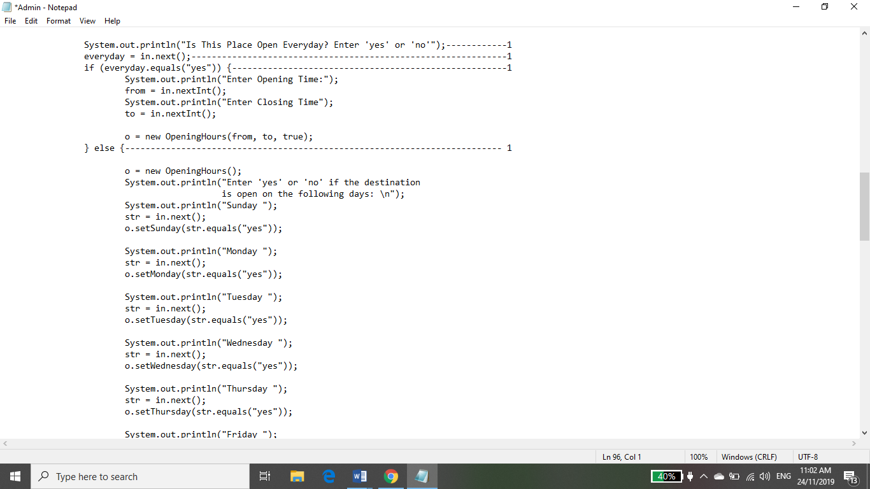

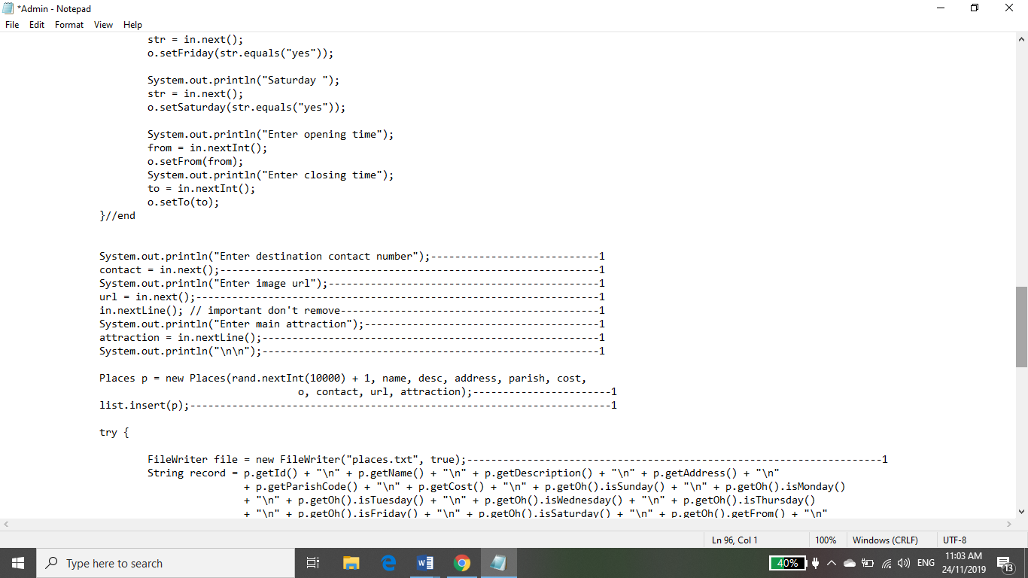

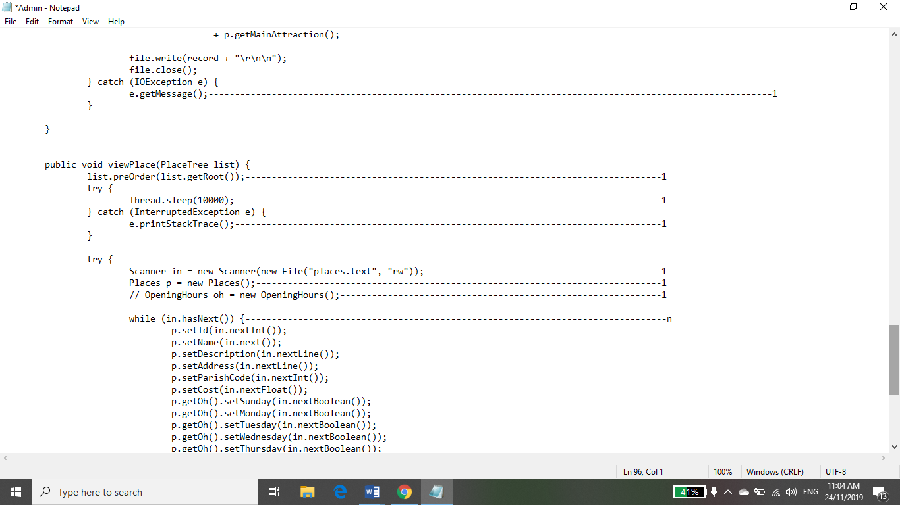

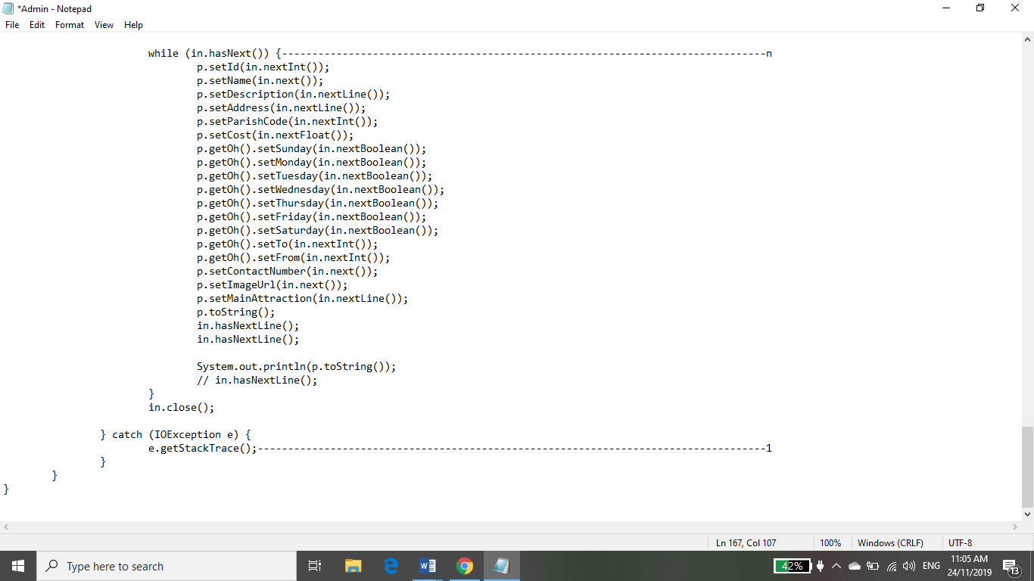

Analysis of Admin.java

f(n) = 49+n(1)

f(n) = n

O(f(n)) = n, linear

## Driver.java

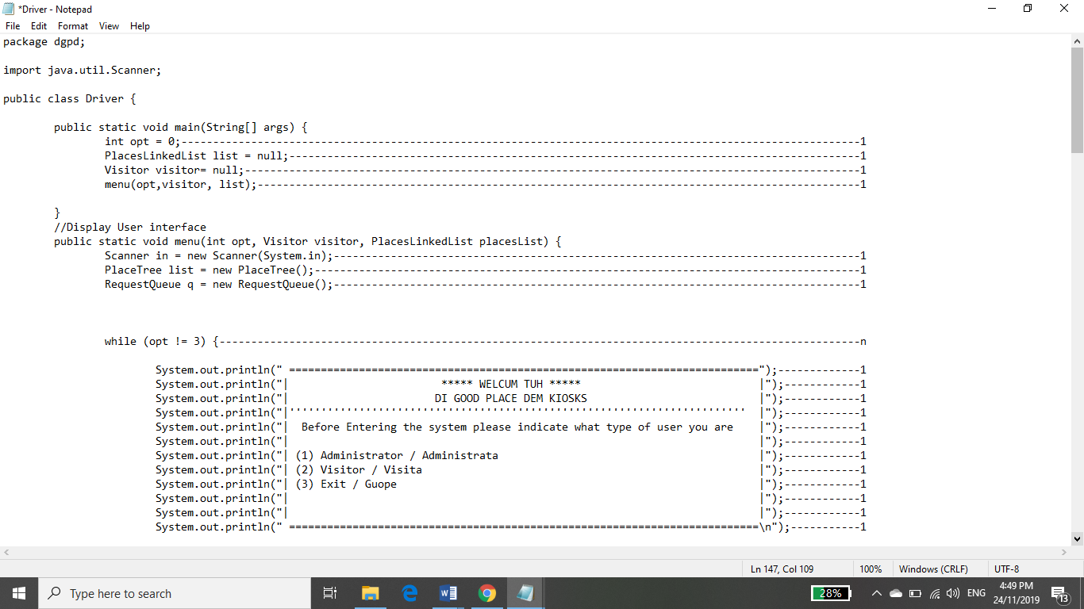

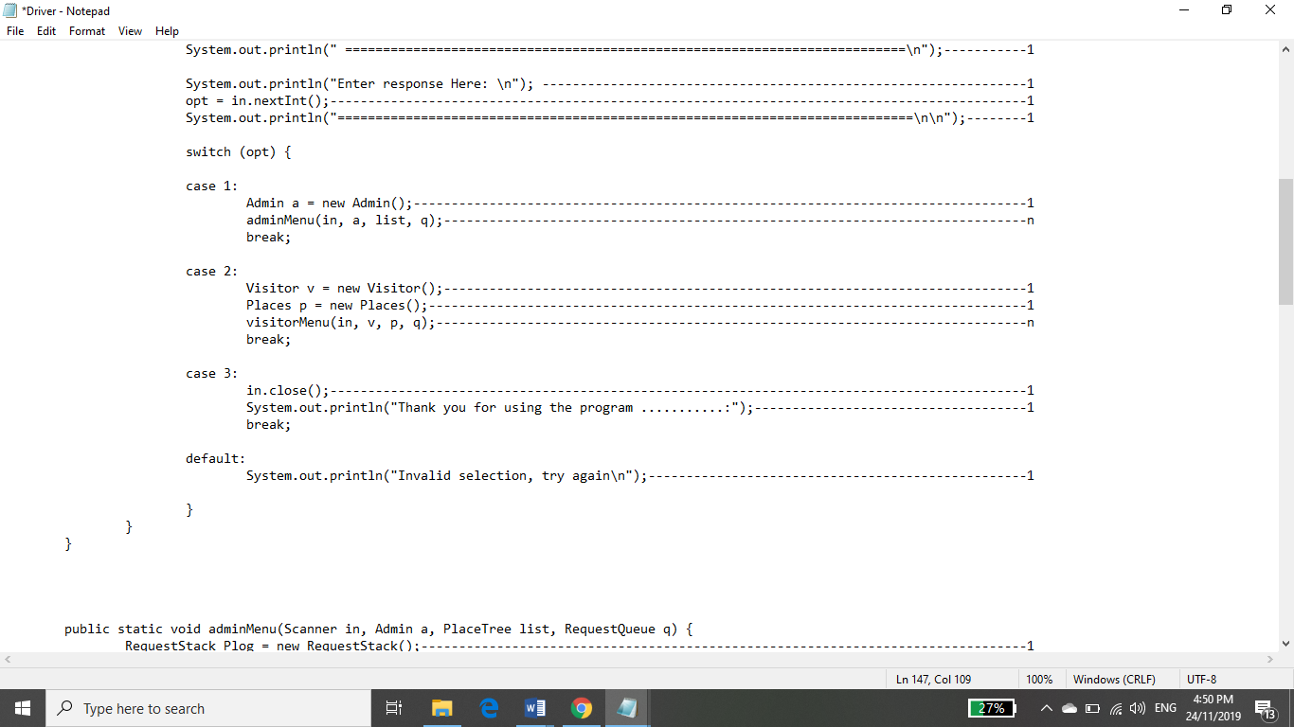

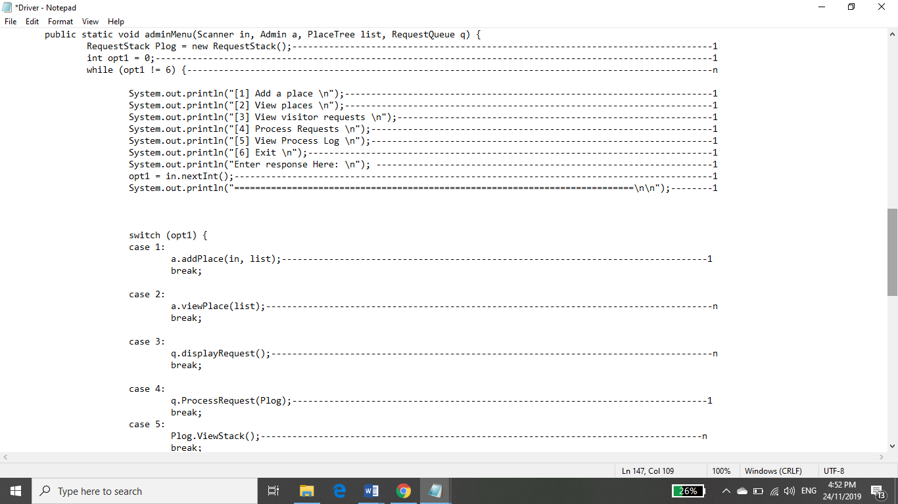

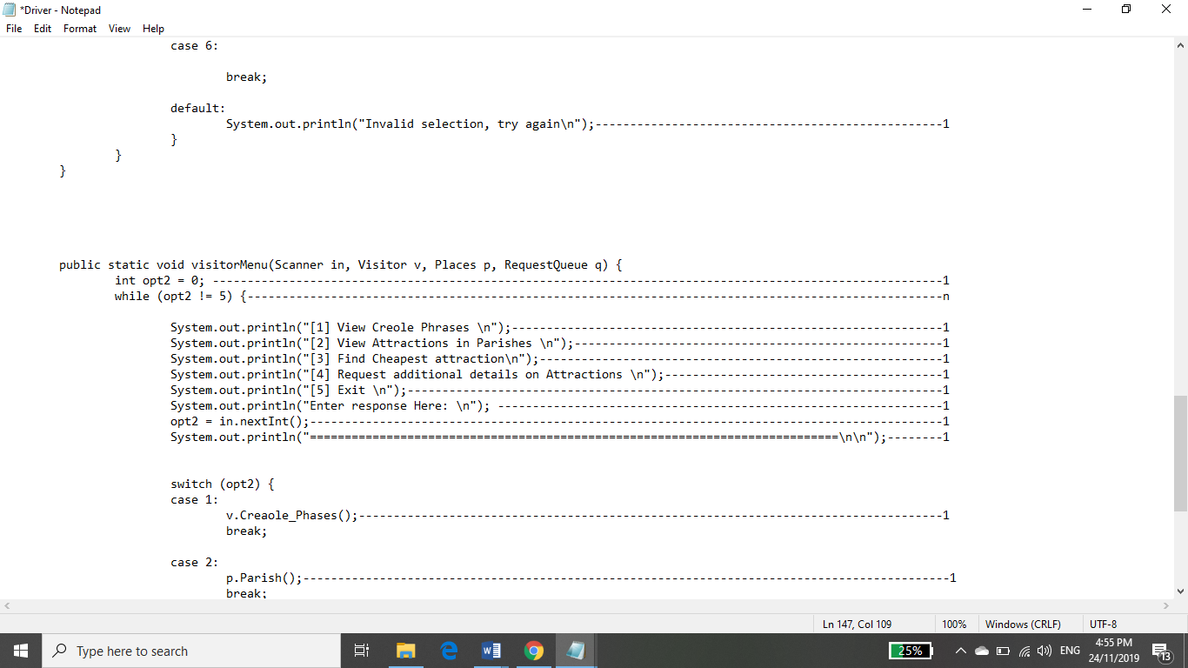

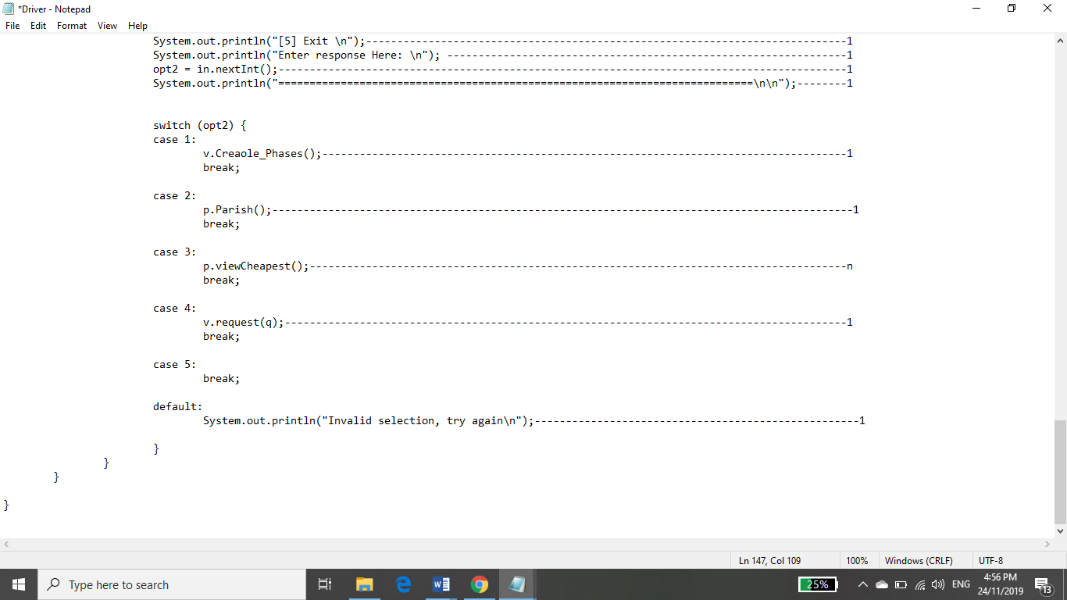

Analysis of Driver.java

f(n)= 4+(3(n+16(1+n+n+1+n+1)))+ 1(n+8(1+1+n+1+1))))

f(n)= 4+(3(n+16(3n +3)))+ 1(n+4))))

f(n)=4+(3n+48(3n+3))+ n+ 4

f(n)= 8+(3n+144n+ 144)+n

f(n)= 8+144+ 3n+144n+n

f(n)= 152+ 148n

f(n)= n

O(f(n)) = n, linear

## OpeningHours.java

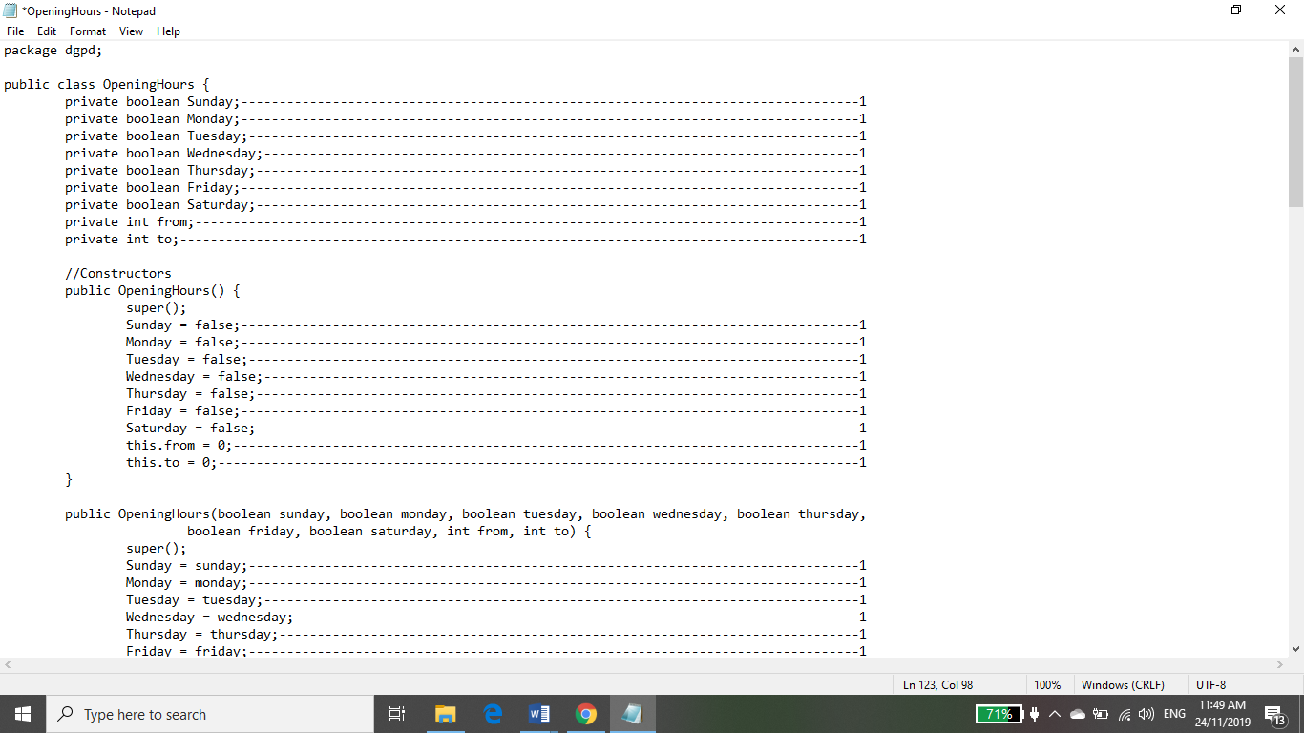

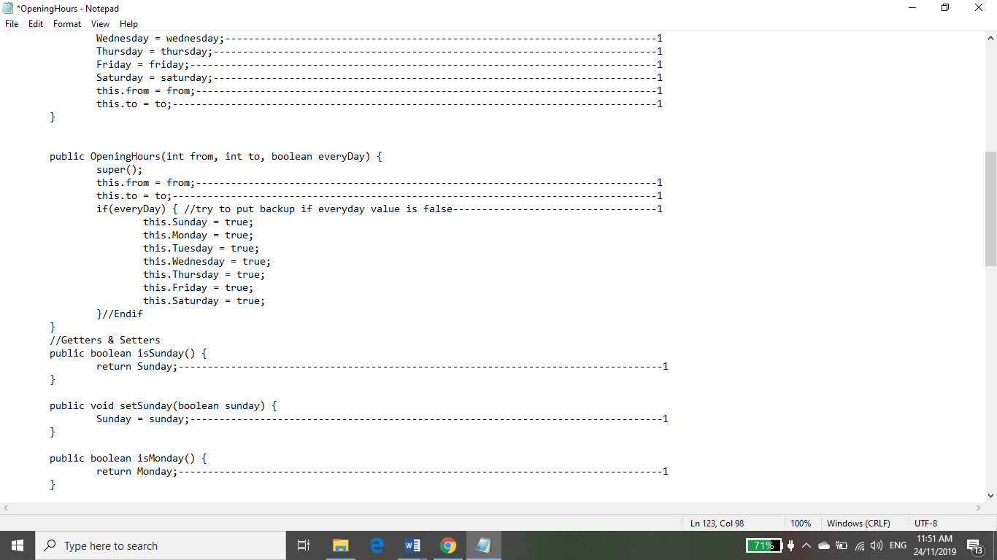

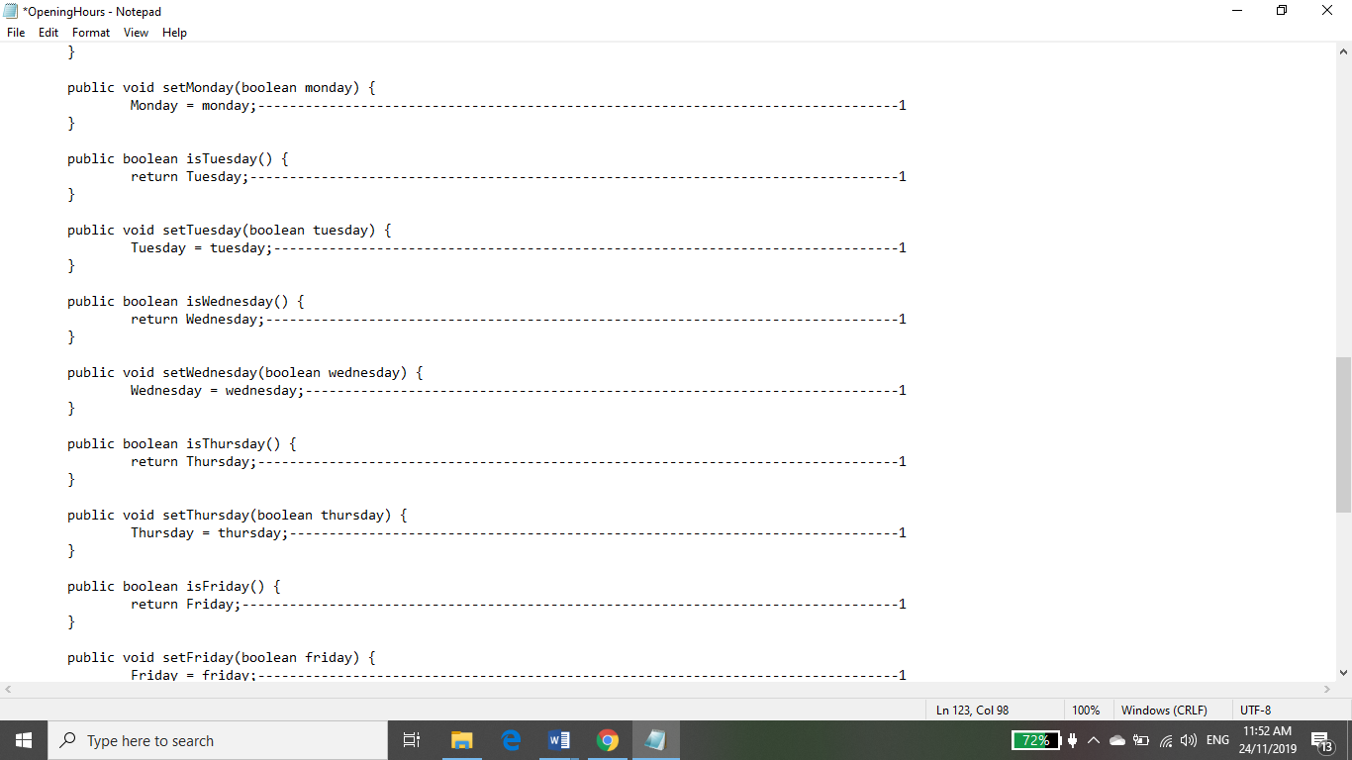

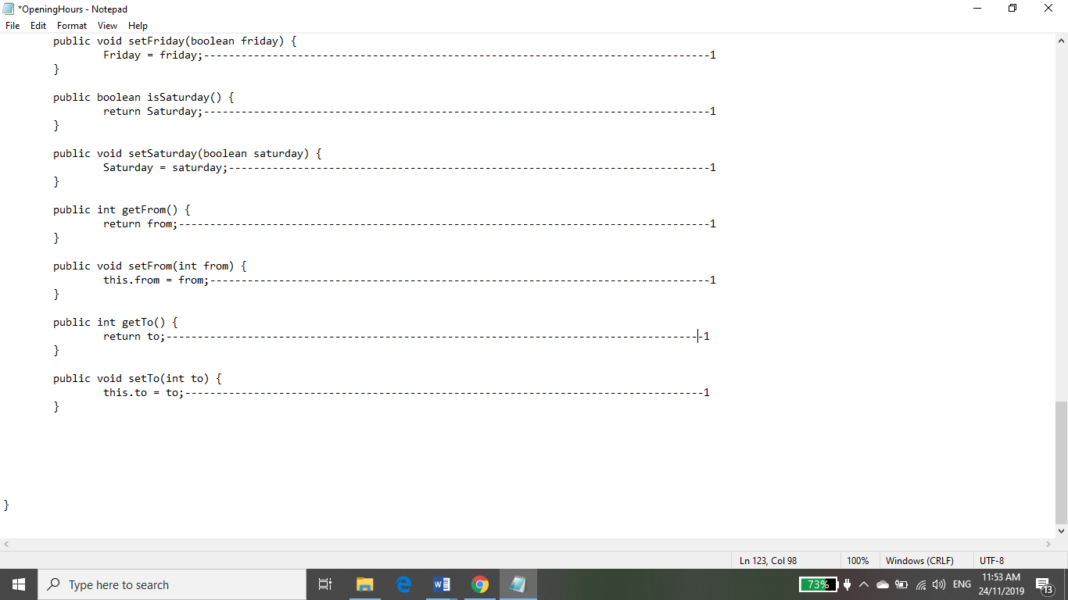

Analysis of OpeningHours.java

f(n) =9+(9)+(9)+(3)+ 18

f(n)= 48

O(f(n)) = 1, Constant

## Places.java

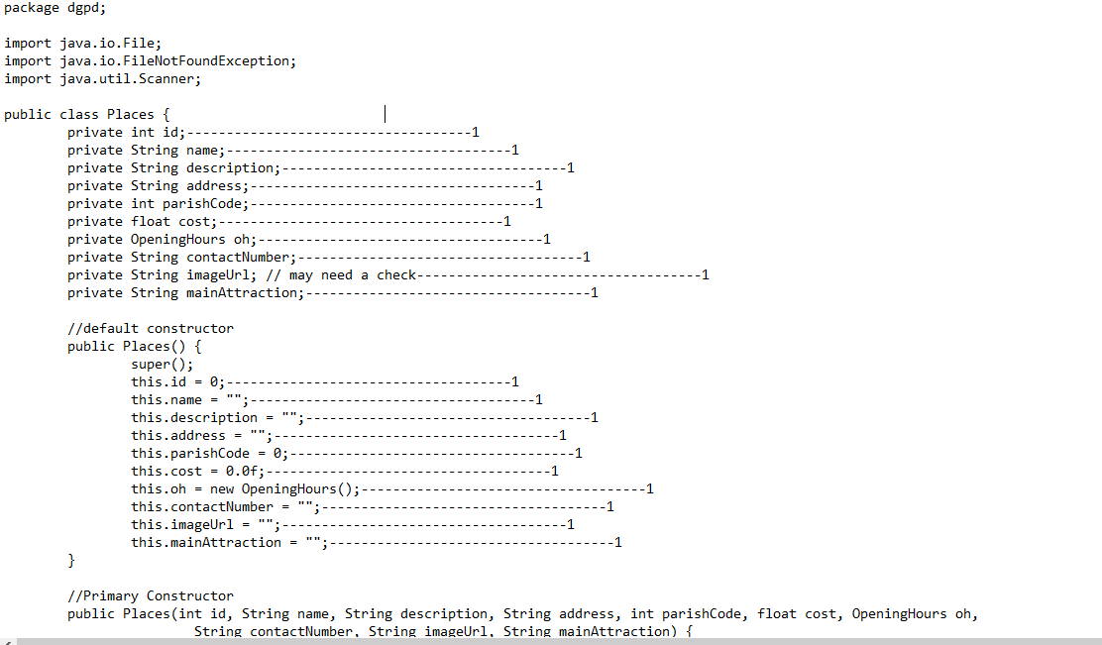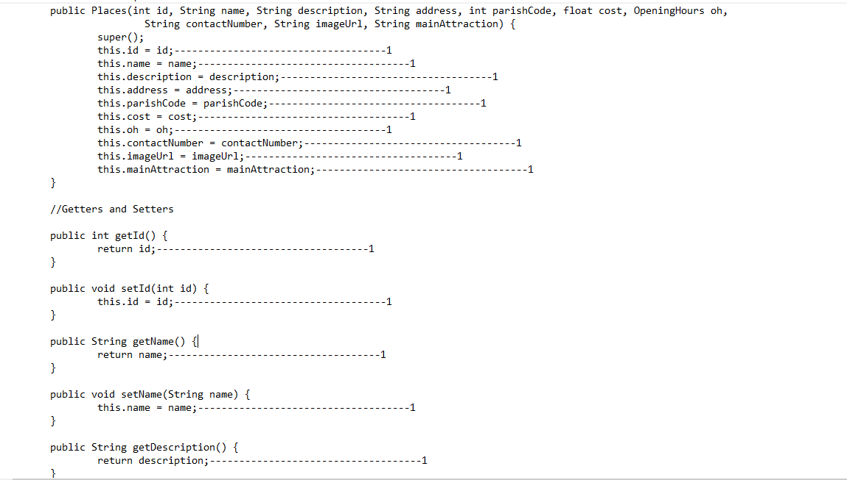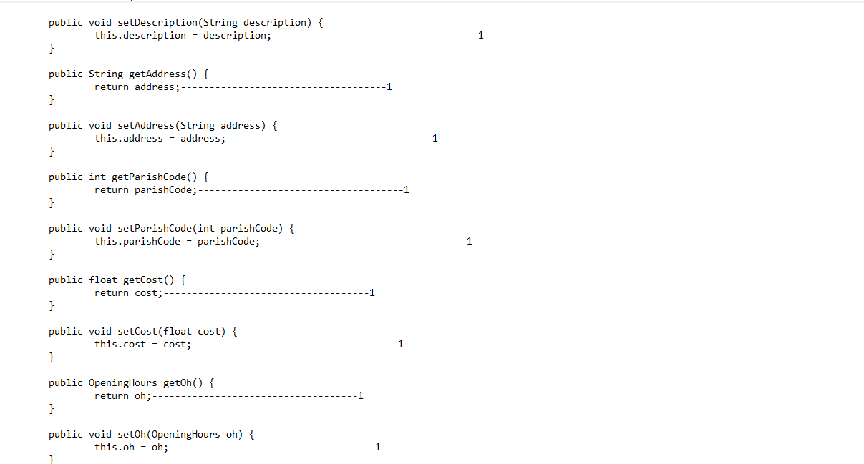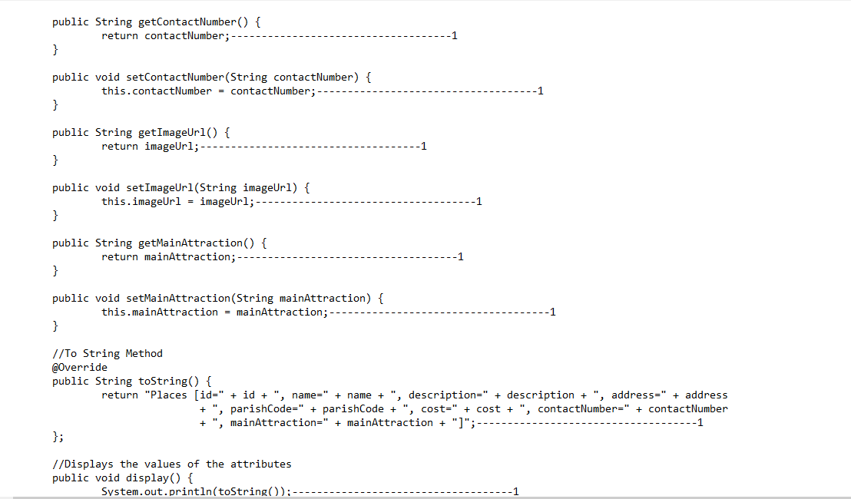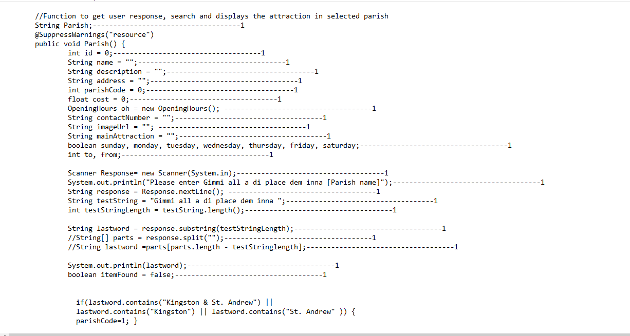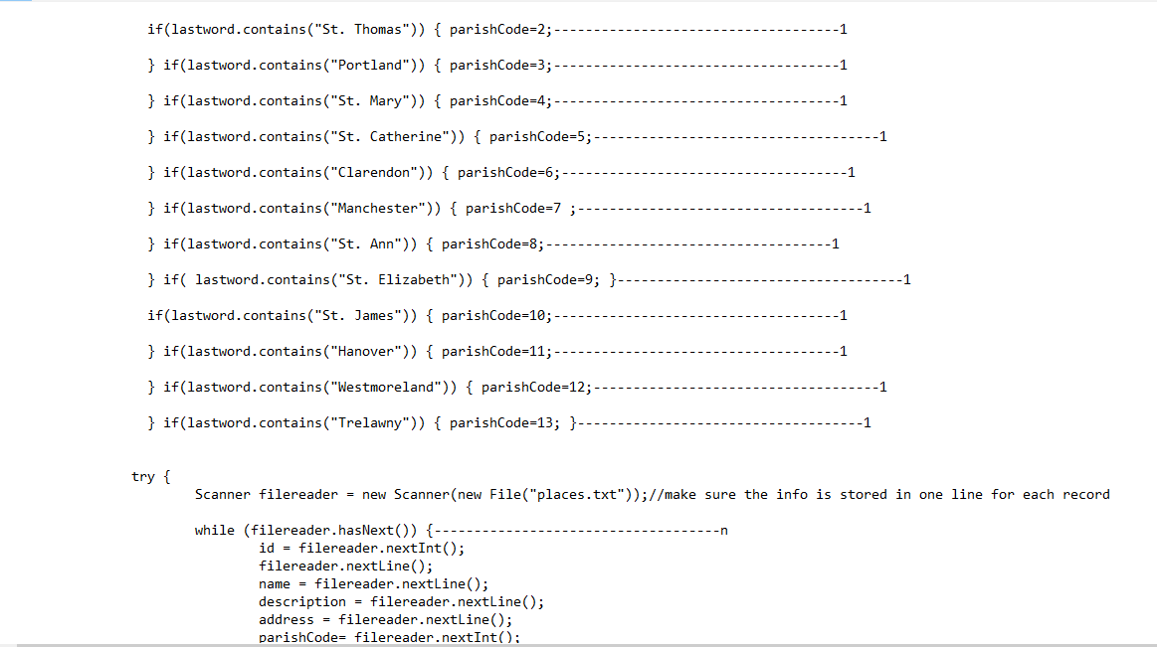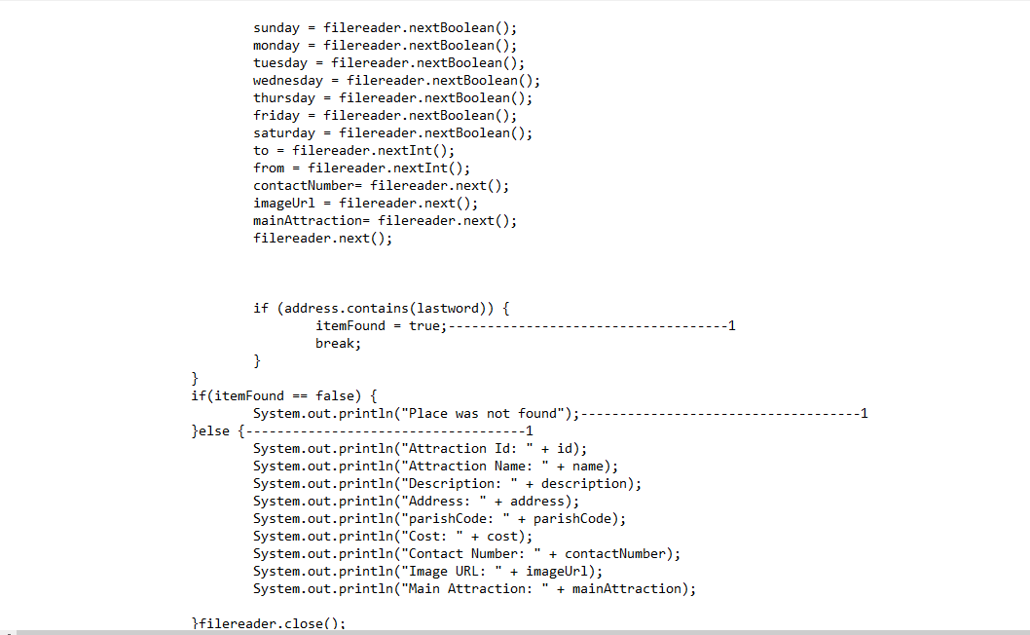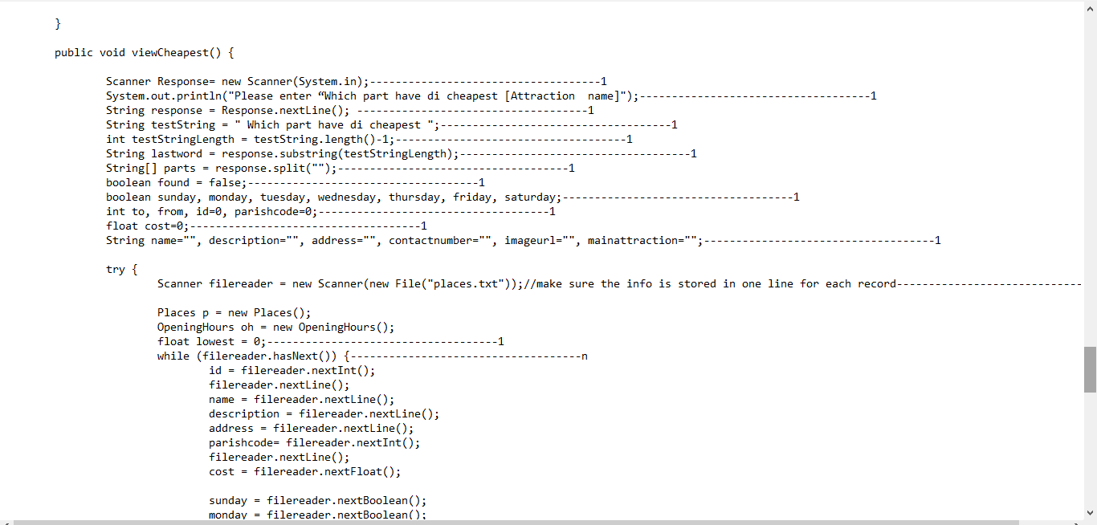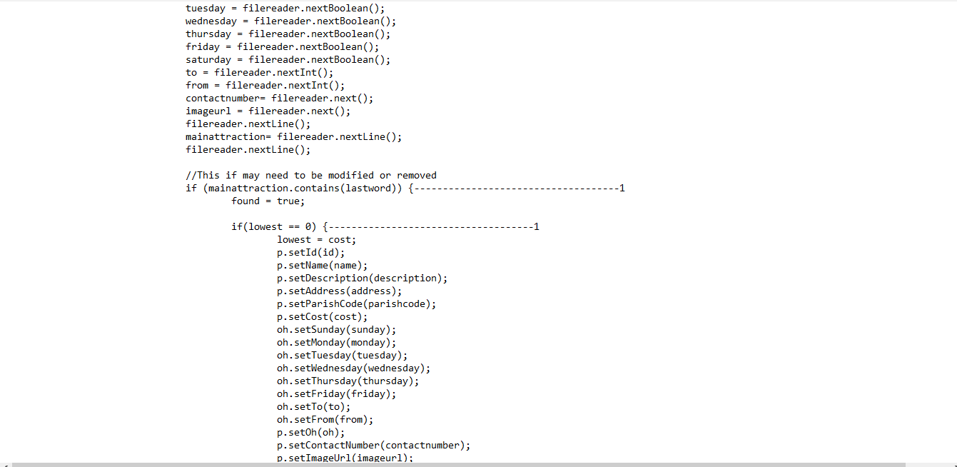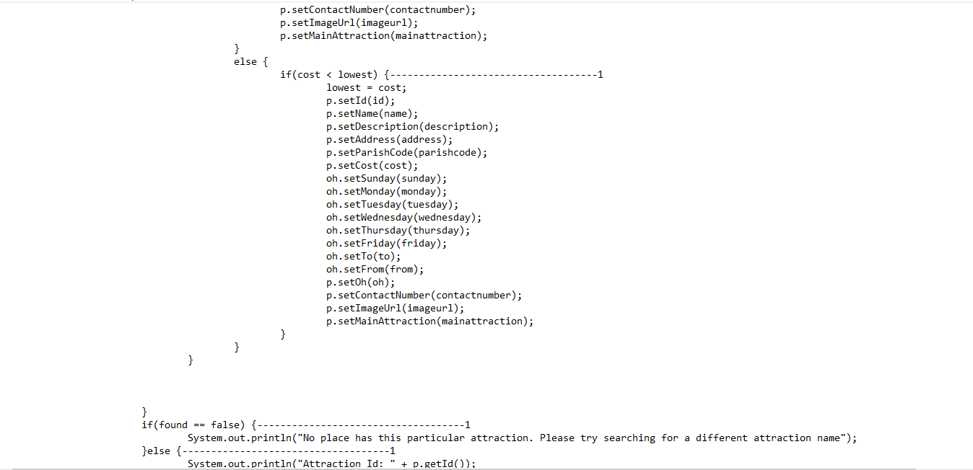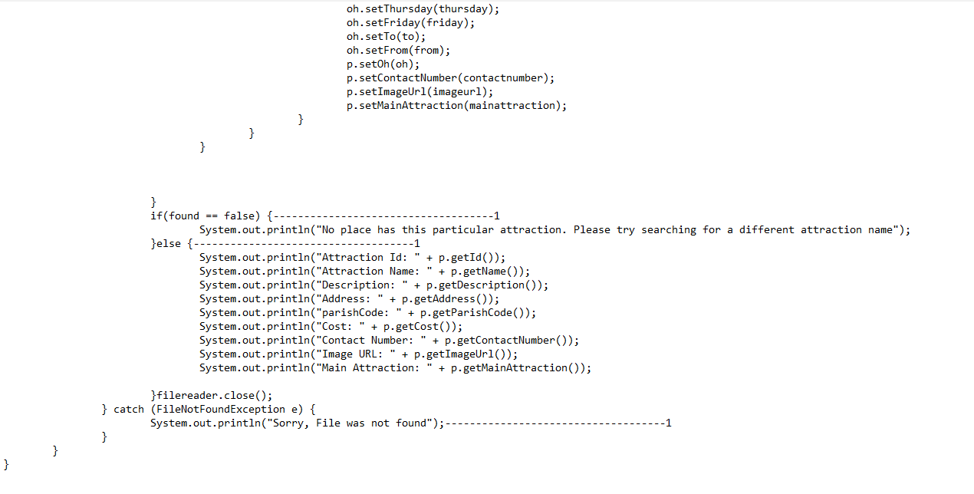

Analysis of Places.java

f(n)=(10)+(10)+(10)+20+(1)+(1)+1+(20)+(1)+12+(n)+(1)+(1)+(1)+(1)+(12)+(2)+(n)+(1)+(1)+(1)+(1)

f(n)=86+n+18+n+4

f(n)=86+18+4+n+n

f(n)=108+(2n)

f(n)=2n

f(n)=n

O(f(n))= n, linear

## PlacesNode.java

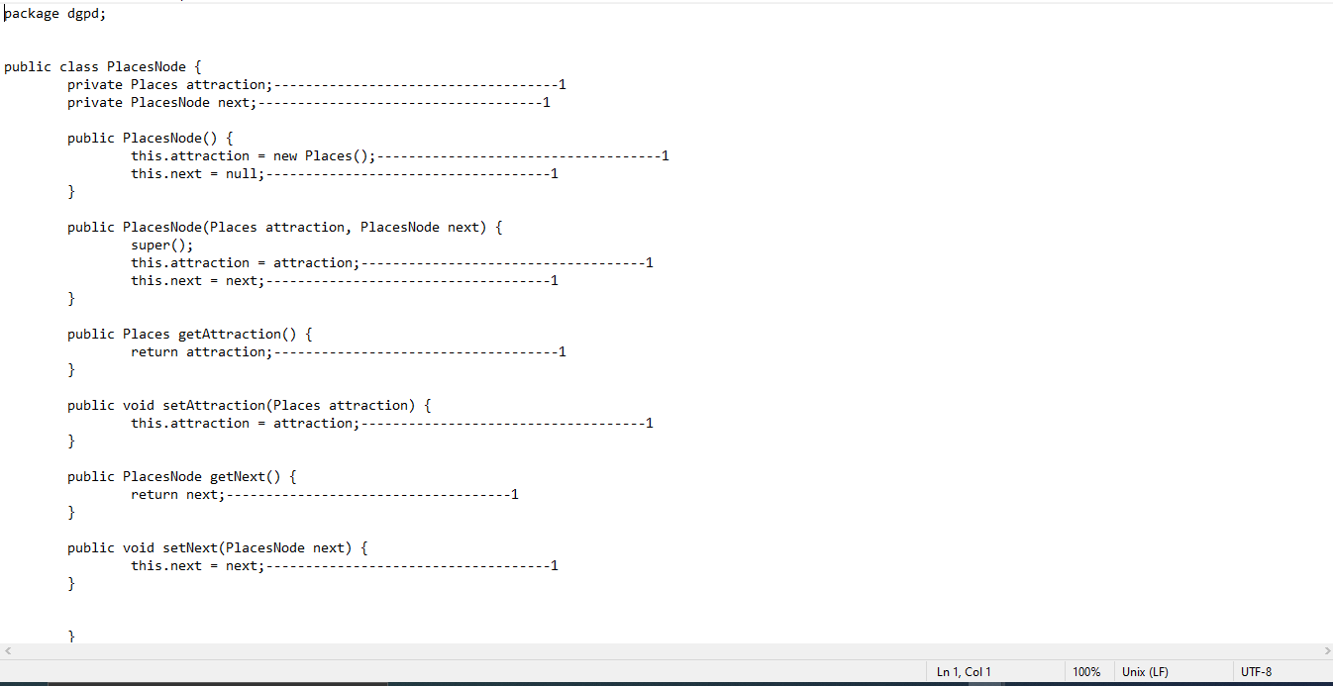

Analysis of PlacesNode.java

f(n)=1+1+1+1+1+1+1+1+1+1

f(n)= 10

f(n)= 1

O(f(n))= 1, Constant

## PlacesTree.java

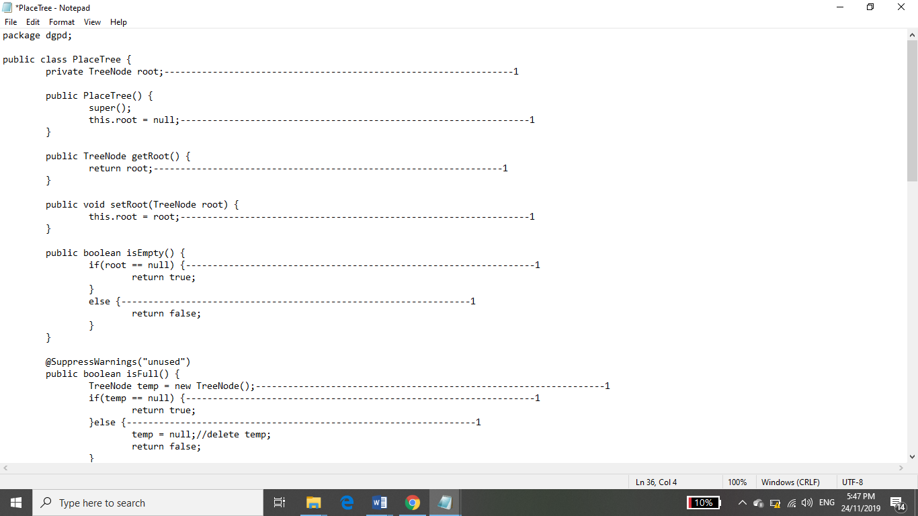

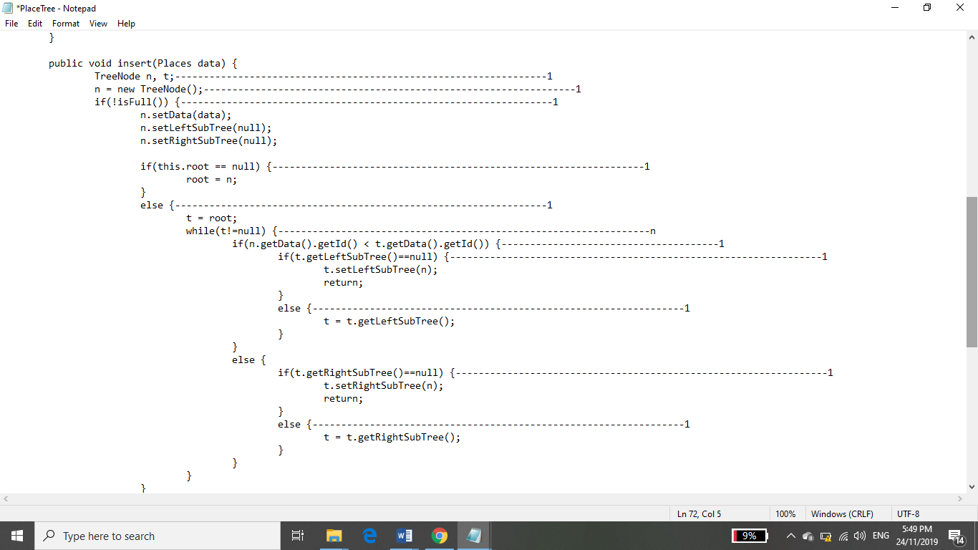

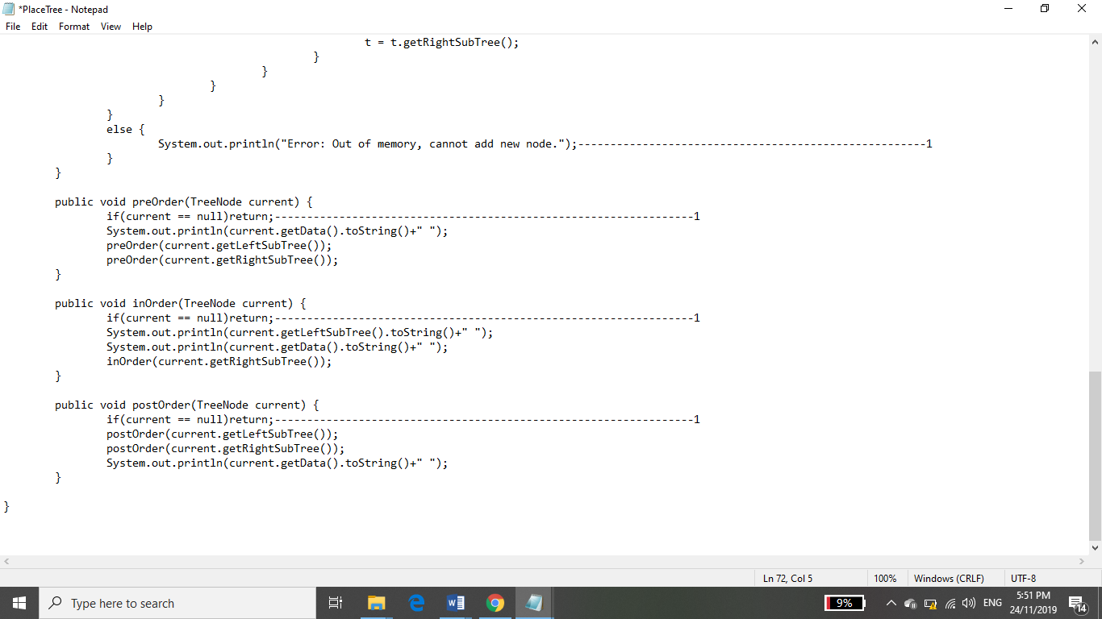

Analysis of PlacesTree.java

f(n) = 14(n(1)) +7

f(n)= 14n +7

f(n)= n

O(f(n)) = n, linear

Request.java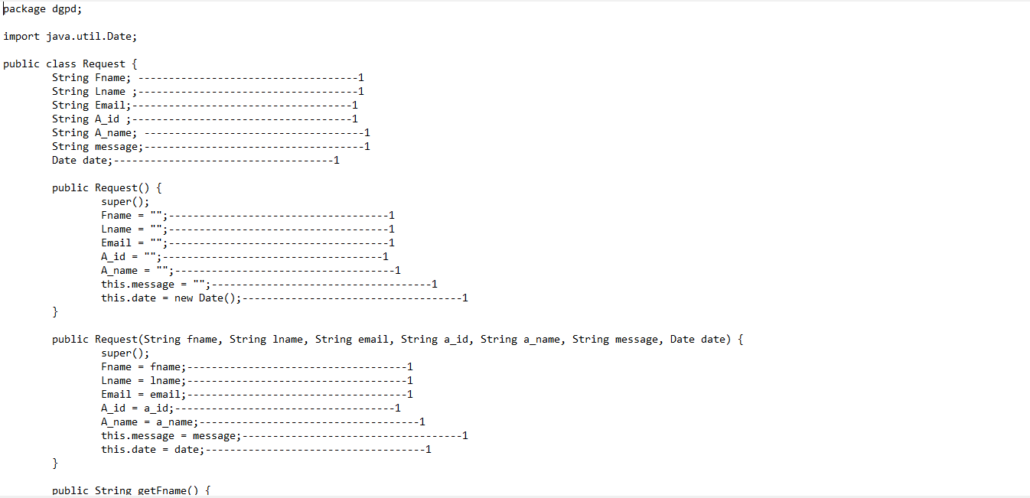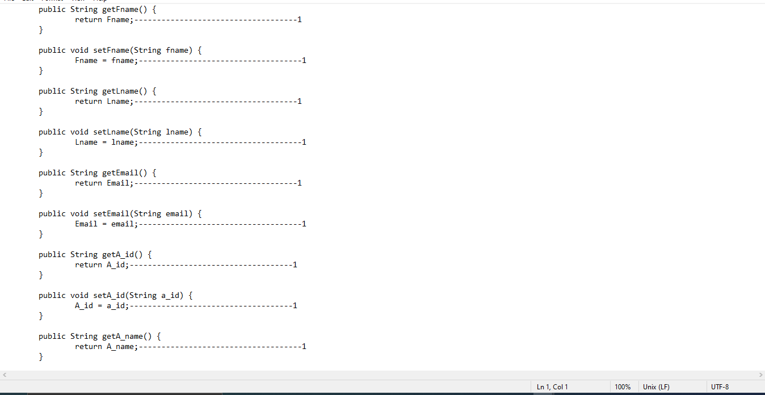

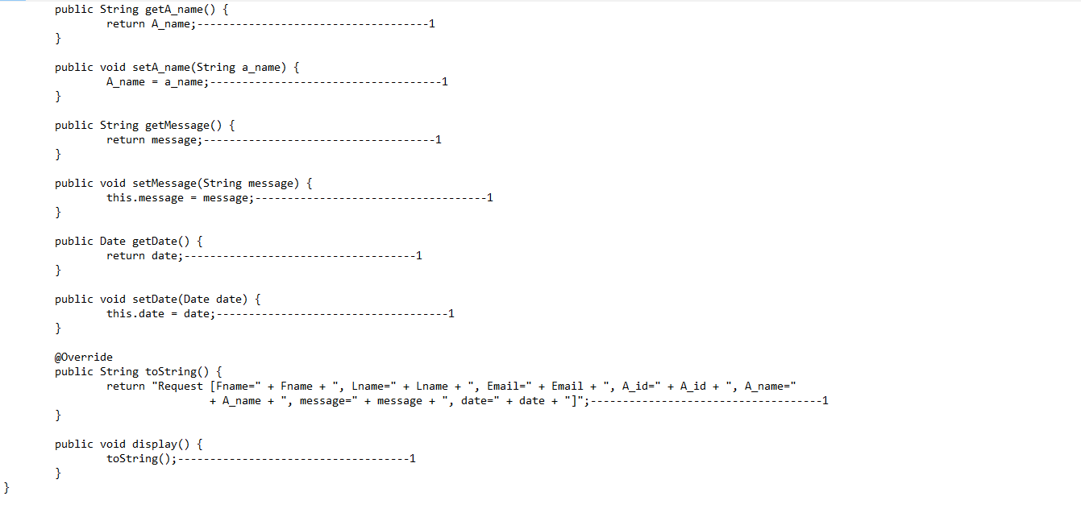

Analysis of PlacesTree.java

f(n)=7+7+7+ 16

f(n)= 37

f(n)= 1

O(f(n))= 1, Constant

## RequestNode.java

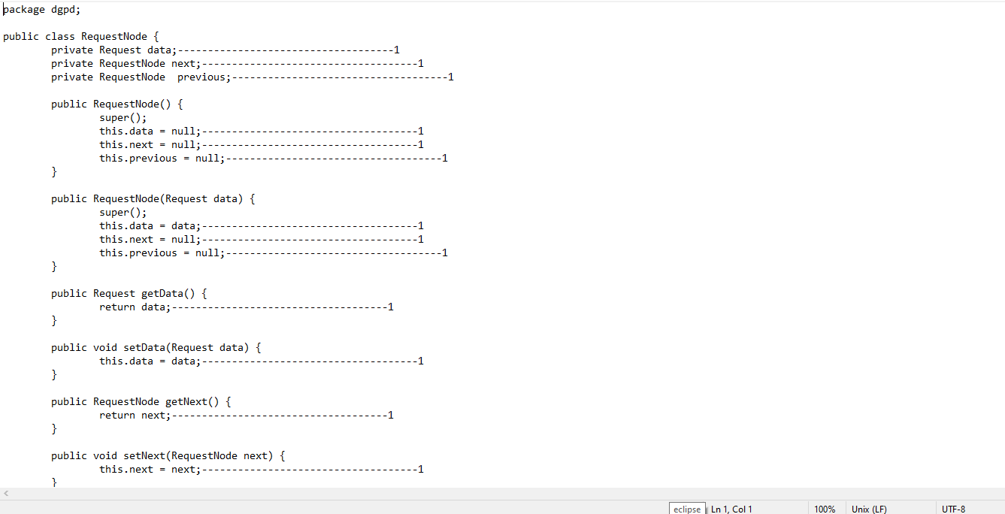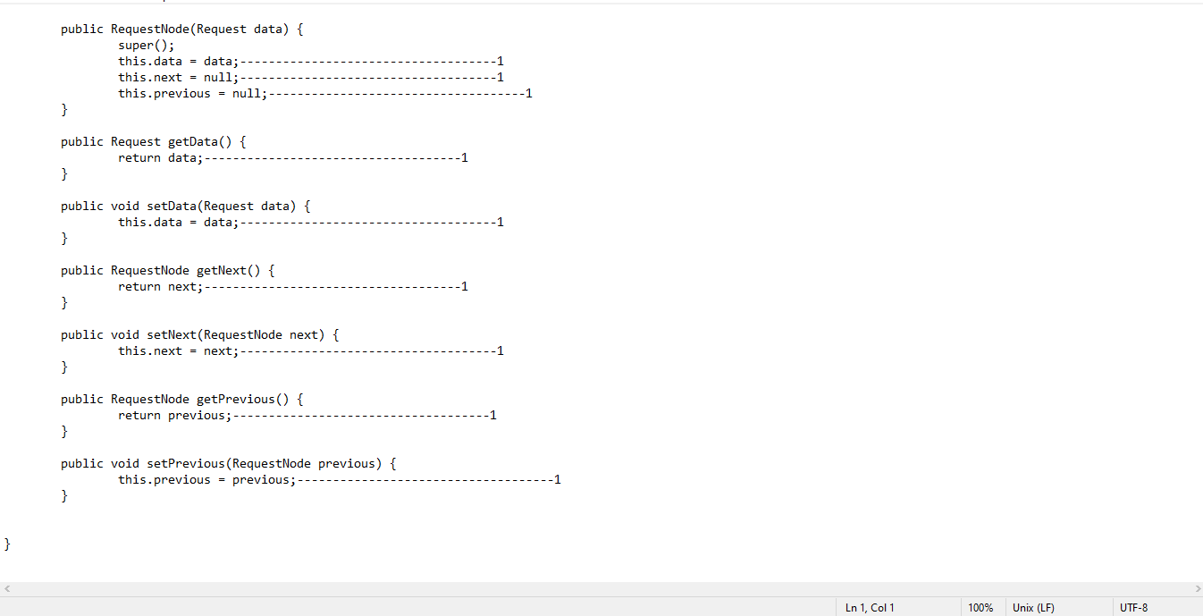

Analysis of RequestNode.java

f(n)= 3+3+3+(1)+(1)+(1)+(1)+3+(1)+(1)+(1)+(1)+(1)+(1)

f(n)= 22

f(n)= 1

O(f(n))= 1, Constant

RequestQueue.java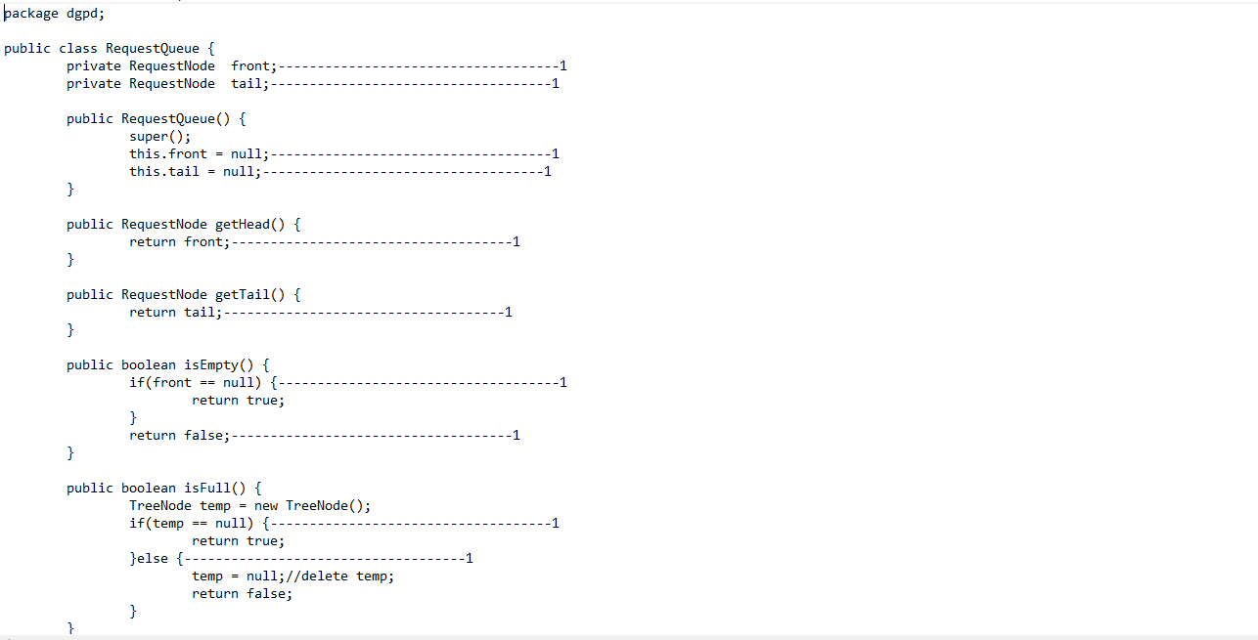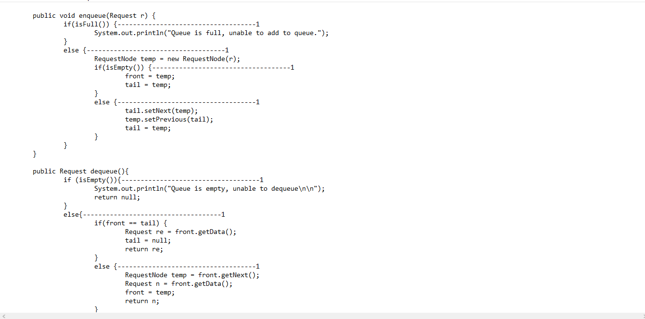

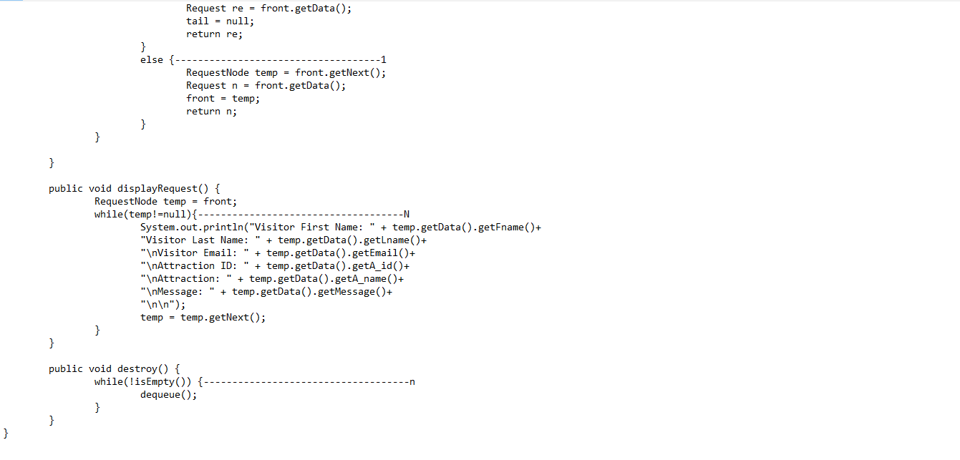

Analysis of RequestQueue.java

f(n)=1+1+1+1+1+1+1+1+1+1+1+1+1+1+1+1+1+n+n

f(n)=17+(2n)

f(n)=2n

f(n)=n

O(f(n)= n, linear

## RequestStack.java

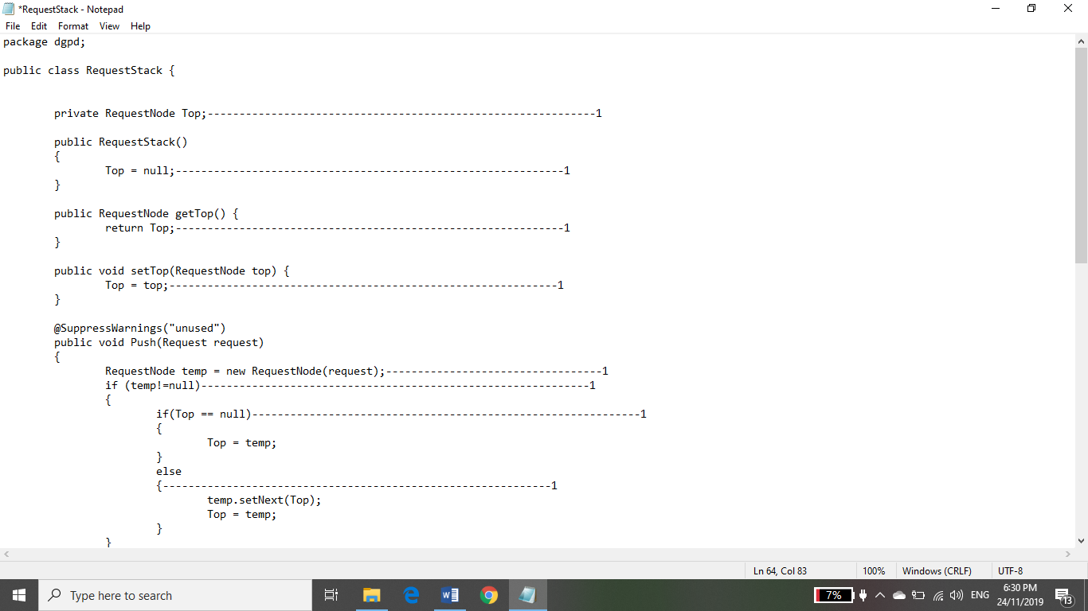

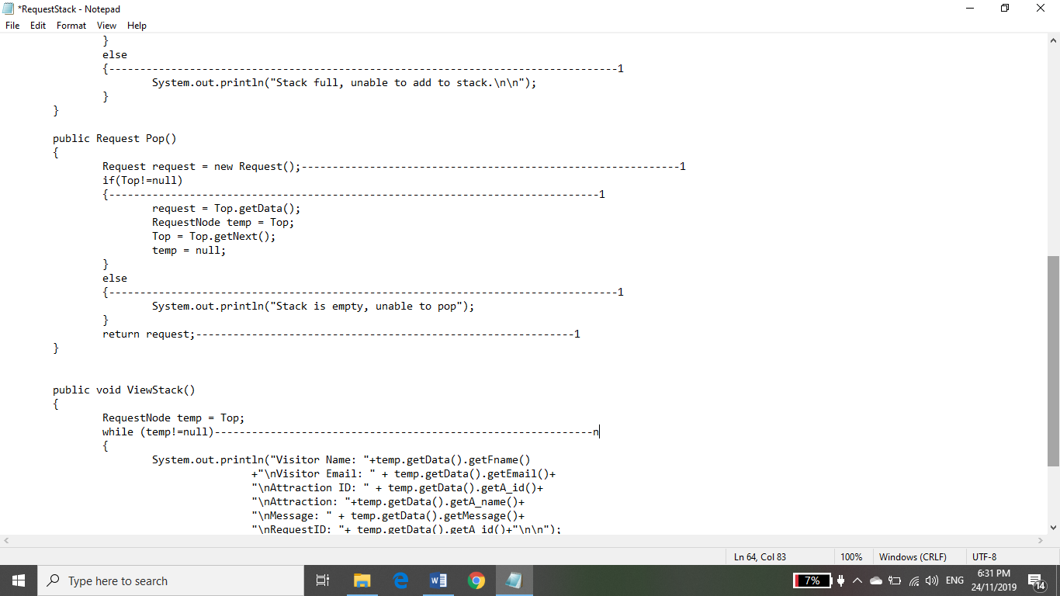

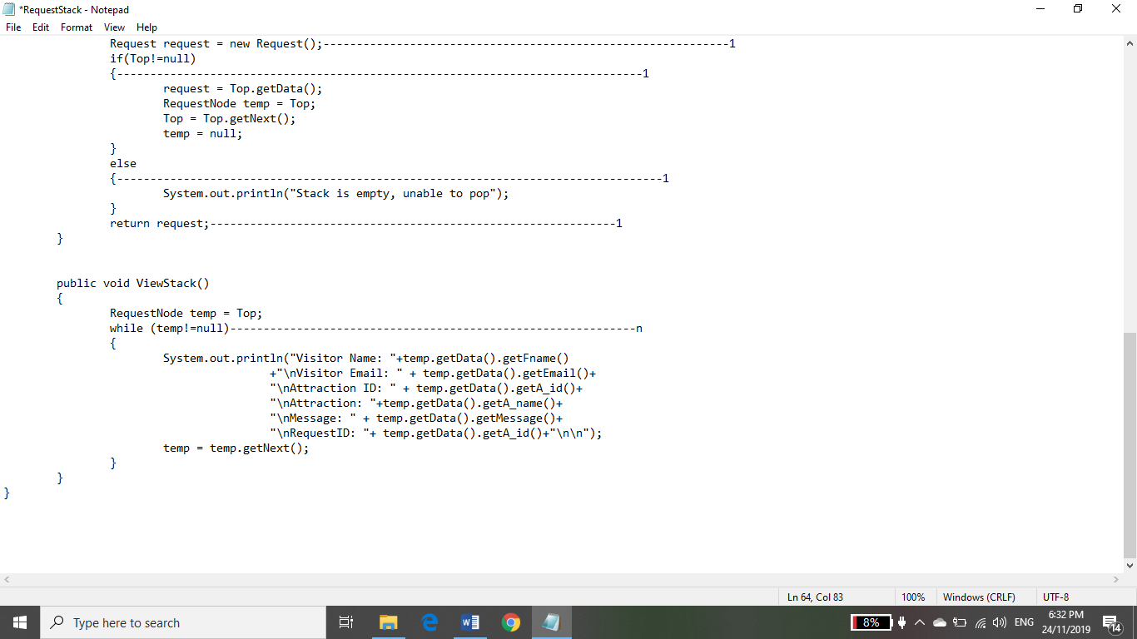

Analysis of RequestStack.java

f(n) = 13 + n

f(n)= n

O(f(n)) = n, linear

## TreeNode.java

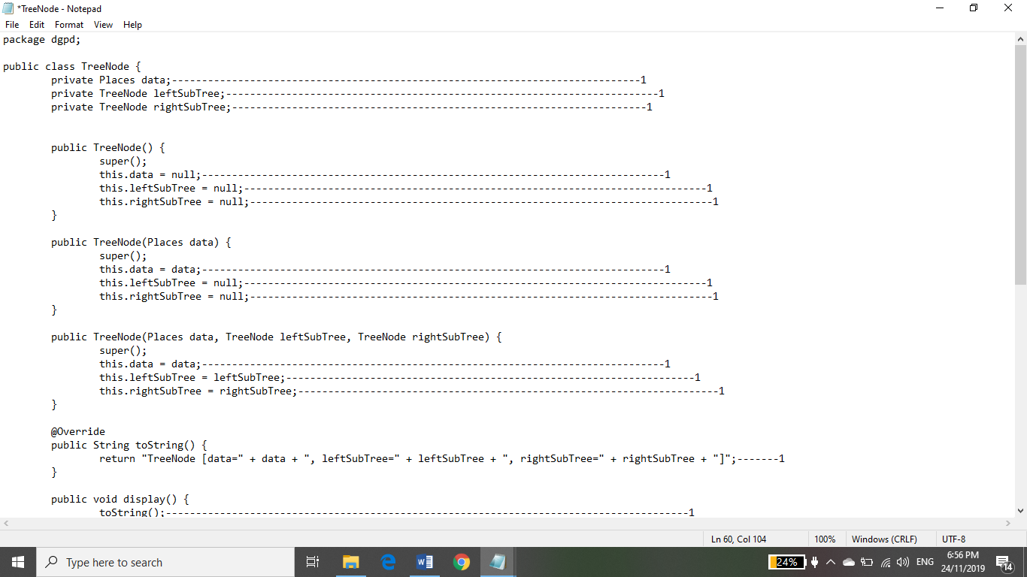

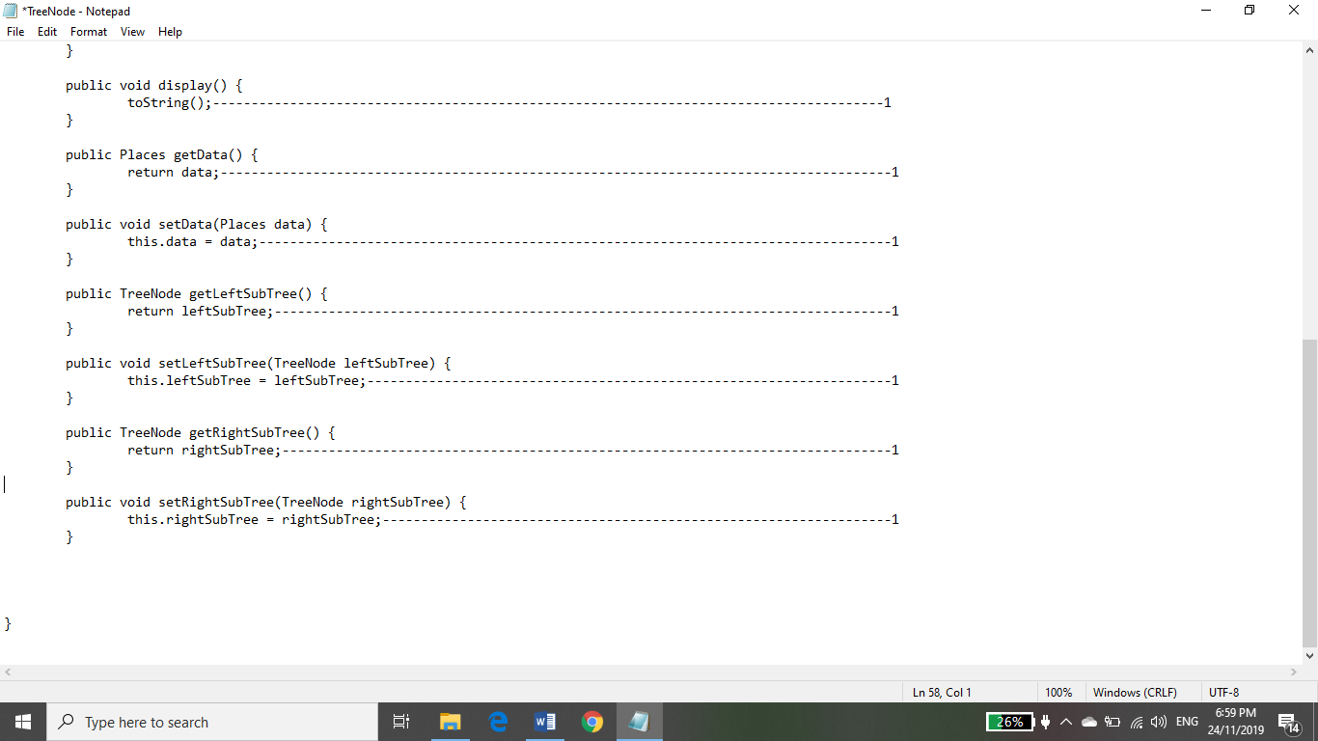

Analysis of TreeNode.java

f(n) = 3+3+3+3+ 8

f(n)= 20

f(n)= 1

O(f(n)) = 1, Constant

## Visitor.java

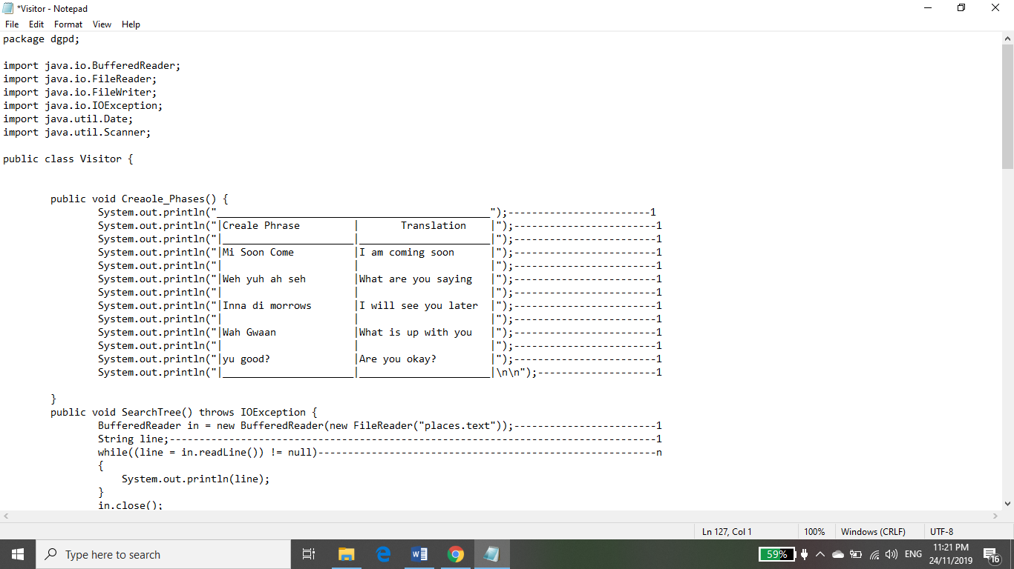

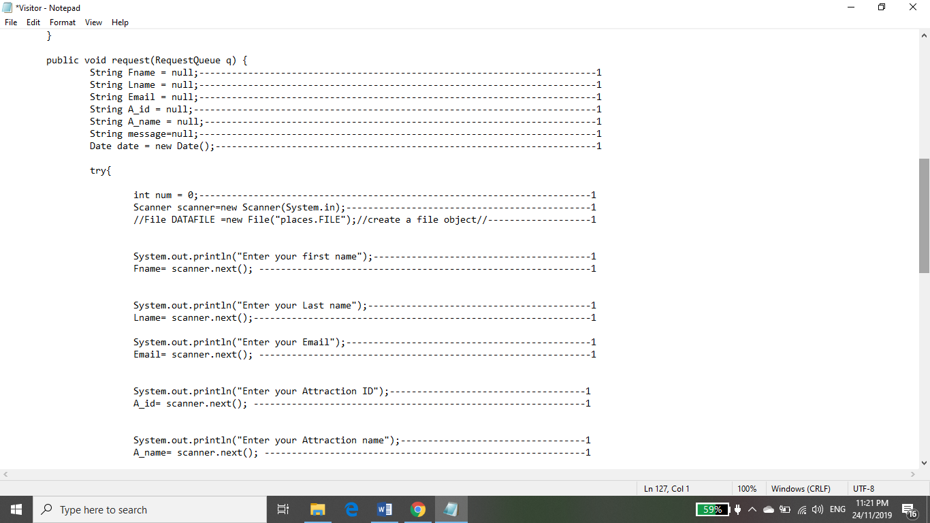

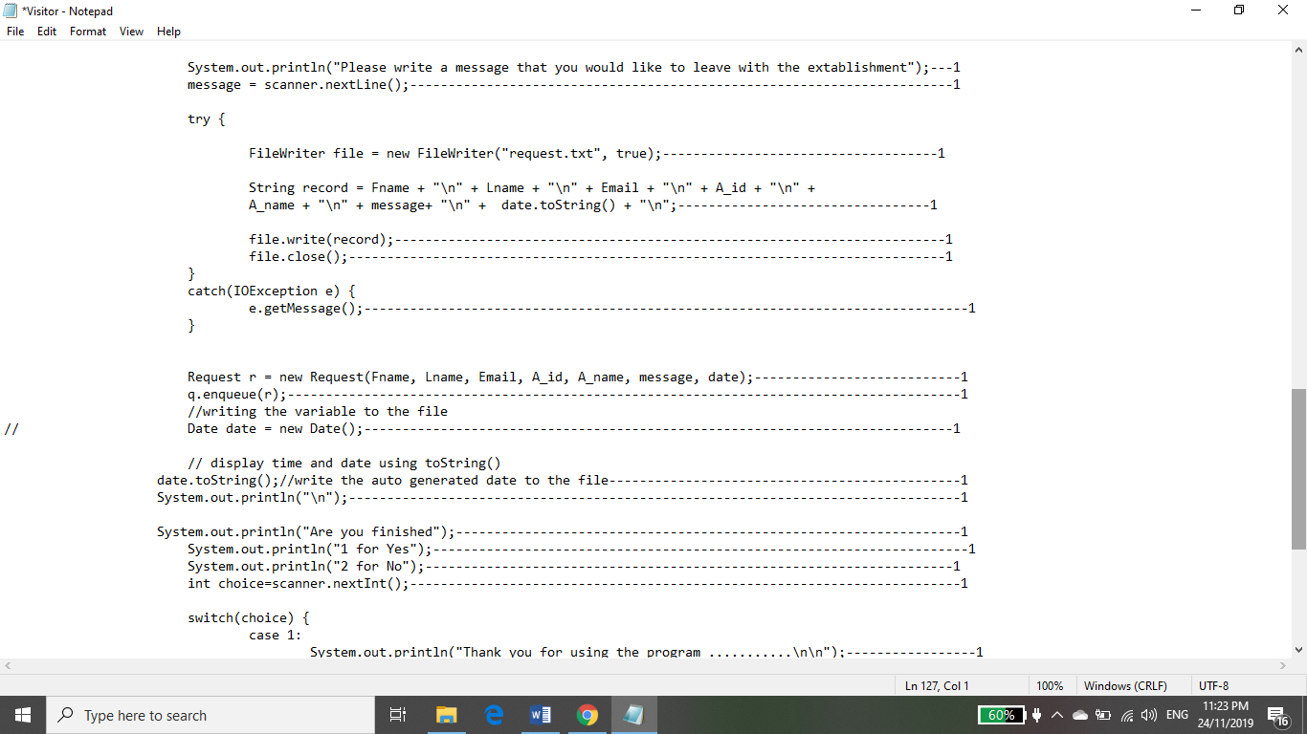

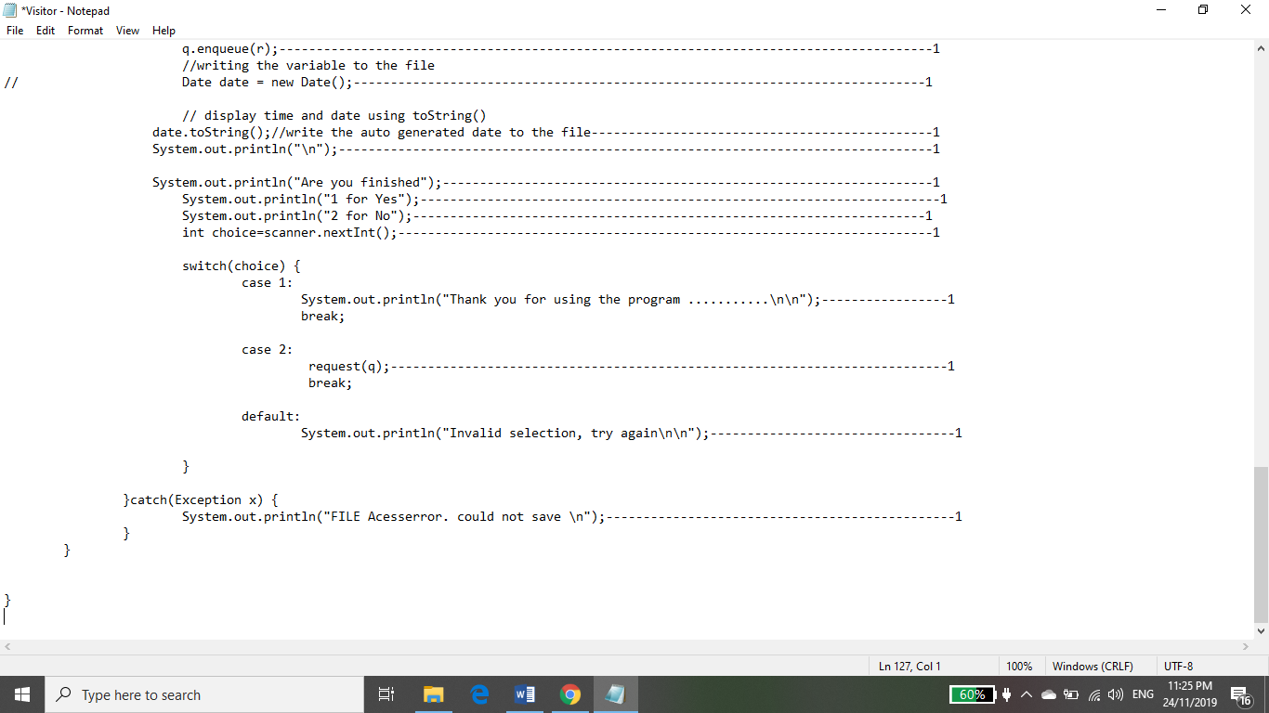

Analysis of Visitor.java

f(n) = 13+(2)+ n+(7(15(4) +(1)+ 13

f(n)= 449 +n

f(n)= n

O(f(n)) = n, linear